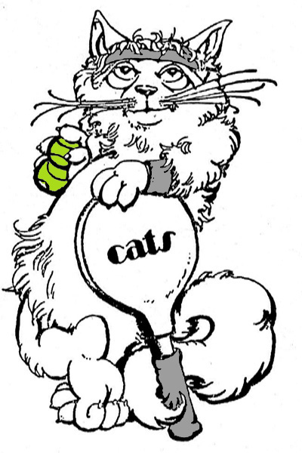
C.A.T.S. Spring Fling

Saturday, May 18, 2024

TENNIS: Glenview Tennis Club
1800 Wagner Road, Glenview, IL
Check-in: 4:30pm Tennis: 5:00-8pm (4 out of 6 round robin)

DINNER/PRIZES: Hackney’s on Lake, 8:00-11pm
1514 E. Lake Ave., Glenview, IL

Dinner Choices: Hackney Burger(cheese), Reuben Sandwich, Grilled Chicken Sandwich, Chicken Avocado Melt, Chicken Caesar Salad, vegetarian options available. Fries and non-alcoholic drinks included. You pay for alcoholic drinks, onion rings, etc.

COST: Tennis and Dinner: CATS Members $52, Non-members $57
Tennis Only: Members $24, Non-Members $27
Dinner Only: Members $28, Non-members $31

PAYMENTS: Via Zelle to catstreas@gmail.com. Indicate in memo section “May Party” and level of play. Send e-mail to Joyce at weberj05@comcast.net with information below.
By check, make check payable to C.A.T.S., enclose tear-off form and send to Joyce Weber, 9801 Gross Point Road, #204, Skokie, Il 60076. You should get an email receipt of your registration. If you don’t receive one, call Joyce at 773-330-1865 and leave a message.

Sign up early to avoid the wait list!!! Deadline for sign-ups: Wed., 5/15/24.

Please include the following information (Print) with your payment. Circle Flight Level

NAME_______________________________________________________Level 1 2 3

GUEST_______________________________________________________Level 1 2 3

PHONE____________________________E-MAIL____________________________________

