The NY Yankees are in town on Tuesday, August 7--
enjoy a summer evening with CATS friends.

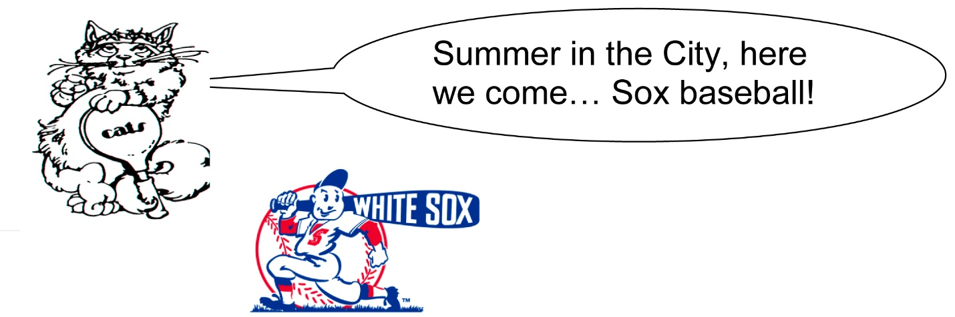

Baseball season is in “full swing”!! Save Tuesday, August 7 for a fun, meet-up style event, when the White Sox take on the New York Yankees! CATS’ pregame will start at Connie’s Pizza, 2373 S. Archer, where we’ll enjoy good food and drink, park free, and have a round-trip game shuttle. It’s self-pay all evening; the Sox will have tickets available -- right field bleachers with a good view at a ticket cost of $30 each, collected at Connie’s.

Event leader is Jim Vahey; please RSVP so we have a total count for the restaurant and the shuttle: cell # 773-294-7752 or e-mail to jimvahey@sbcglobal.net. Hope that you can attend! Invite non-CATS friends, it’s ok with an RSVP.

We’ll meet at Connie’s beginning at 4:30 PM and reserve the shuttle for 6:15 PM to allow time for Jim to purchase our tickets, which we will have just paid for. Connie’s Rocks!

